From : OC MLAU | To : All OC Wings & OC Sqns
Email : aslyauyeung@yahoo.com.hk | Cc : CO, DCO, CSO, OC Gps, HQ
Ref : ACC-MLAU 2019 - 01 | Date : 11 Dec, 2019

Open Day cum Youth Development Day
Immigration Service Institute of Training and Development (ImmD school)
入境事務學院開放日暨青年發展日
11 January 2020 Saturday 1000-1600hours

Immigration Service Institute of Training and Development will have their Open Day cum Youth Development Day (入境事務學院開放日暨青年發展日) on 11 January 2020 and our members are invited to attend. This is a good opportunity to understand the background and service of Hong Kong Immigration Department, thus benefiting those determine to develop their future career at the aspect of disciplinary forces.

Date / Time | 11 January 2020, Saturday, 1000-1600 hours  (Specific time slot reserved for ACC members: 1400-1600 hours)
Venue | Immigration Service Institute of Training and Development  82 Castle Peak Road (Castle Peak Bay), Tuen Mun, N.T.
Meeting Time / Point | 1315 hours at Kowloon Tong MTR Exit D
Target Participants | All members
Age | 12+
Dress Code | No.2A or 3A / Sqn Polo
Quota | > 40
Closing Date | 2359hrs 04 Jan 2020 (Saturday)
Application | Through Sqn/Unit OC by attached Application Form to mlauhkacc@gmail.com
Remark: | Transportation will be available from Kowloon Tong to ImmD School and return from ImmD School at 1600 hours to Kowloon Tong

Should you have queries, please contact F/L Alex LEE at alexlee711@gmail.com.

S/L Asly AUYEUNG
OC MLAU
Encl. Application Form

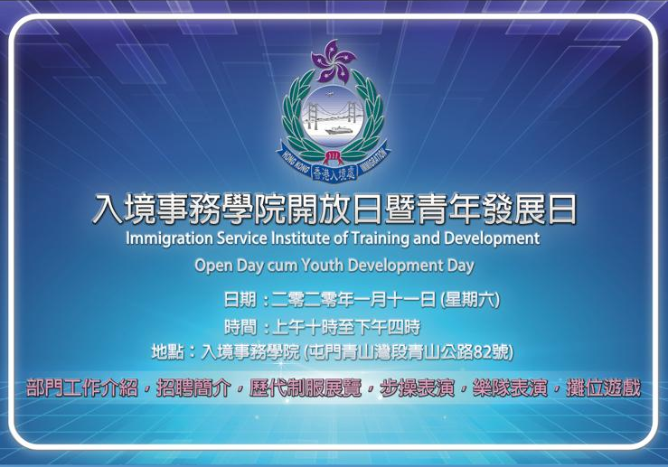

Application Form
Open Day cum Youth Development Day
Immigration Service Institute of Training and Development
入境事務學院開放日暨青年發展日
11 January 2020 Saturday 1000-1600hours

From: OC __________ Unit / Sqn
To: OC MLAU, IA Group (mlauhkacc@gmail.com)
Date: ___________

Please reserve ______ seat(s) for our Unit, and we understand that the final allocation of seats would be subject to the number of applicants.

Name in Block: _________________________ Rank: ____________ Post: ____________
Phone: ____________ Signature: ________________________

List of Application (in order of Priority)
 | Rank | Name (as listed in HKID) | S/N | Age | Mobile | Email
1
2
3
4
5
6
7
8
9
10

